**LEBANESE AMERICAN UNIVERSITY**

**USAID – HIGHER EDUCATION SCHOLARSHIP PROGRAM**

**HES - Volunteering Program Verification Form**

This form is to be used to document volunteering hours. If a student volunteers for multiple organizations, a separate form must be used for each organization. **This form must be turned in by the 28th of each month, the latest.**

I certify that the scholar Khalil Salaheddine completed a total of 12 hours of service at InnovaThrive.

The hours were completed hours as per the below:

Hours # 0 (date) _2/12 – 6/12_ (initials of supervisor) __A.K.___

Hours # 0 (date) _9/12 – 13/12_ (initials of supervisor) __A.K.___

Hours # 0 date) _16/12 – 20/12 (initials of supervisor) __A.K.___

Hours # 12 date) _23/12 - 27/12 (initials of supervisor) __A.K.___

Brief description of the activities the scholar performed or participated in:

Research Topic 1: AI in Real-Time Disease Outbreak Mapping  
Definition: Using AI to track and predict the spread of infectious diseases globally.  
Technologies:  
  
  
Predictive modeling and simulation tools for outbreak analysis.  
  
  
AI-driven mapping of disease spread patterns.  
  
Applications:  
  
  
Real-time tracking of COVID-19 and similar outbreaks.  
  
  
Optimizing healthcare resources based on predicted disease spread.  
  
Statistics: AI reduces response times by 40% in tracking new outbreaks.  
  
Advantages:  
  
  
Faster decision-making and resource allocation.  
  
Disadvantages:  
  
  
Risks of relying on incomplete or inaccurate data.  
  
Challenges:  
  
  
Ensuring the privacy of health data while tracking outbreaks.  
  
Future Research:  
  
  
AI-powered vaccines and treatment development.  
  
  
Collaborating with international organizations for global health monitoring.  
  
Research Topic 2: AI in Sustainable Water Management for Agriculture  
Definition: Exploring AI solutions to manage water resources efficiently in farming.  
Technologies:  
  
  
AI-driven irrigation systems that adapt to weather patterns and soil moisture levels.  
  
  
Predictive analytics for drought and water scarcity forecasting.  
  
Applications:  
  
  
Optimizing water use in crop irrigation.  
  
  
Real-time water quality monitoring in agricultural runoff.  
  
Statistics: Studies show AI-based irrigation systems reduce water use by 30%.  
  
Advantages:  
  
  
Sustainable water use, leading to cost savings.  
  
Disadvantages:  
  
  
High upfront investment in AI-powered infrastructure.  
  
Challenges:  
  
  
Integrating AI solutions in small-scale farms.  
  
Future Research:  
  
  
AI’s potential to support sustainable water management in arid regions.  
  
  
AI-powered systems for water recycling in agriculture.

Written feedback about the scholar’s performance:

Khalil showcases impressive research and analytical skills, tackling multiple complex AI topics. His ability to break down intricate concepts and present them clearly indicates strong problem-solving abilities and attention to detail.

Please rate the overall performance of the scholar at your organization:

|  |  |  |  |
| --- | --- | --- | --- |
|  | Mastery (5) | Proficient (3) | Emerging (1) |
| **Problem solver** | X |  |  |
| **Engaged & Committed** | X |  |  |
| **Open-minded & multicultural** | X |  |  |

Signature

& stamp

__________________________

_

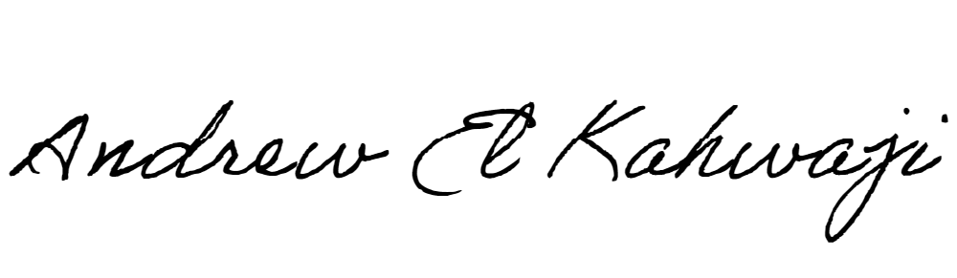

Printed Name _Andrew El Kahwaji_

Date __26/12/2024___

Email __andrew.lifesculptor.coo@gmail.com __

Phone __+961 71 914 378__